15th February 2021
Dear Members,

What a joy during Lockdown January to see our beloved Cornwall featuring so extensively on TV! What has anyone learned that we didn’t know before? Time for another TRA Quiz, an unbelievable three plus years since the last one??

Understandably, TRA members not permanently resident in Trebetherick may be frustrated with being unable to visit during Lockdown. But please note: “overnight stays away from your primary residence are not permitted, including in a holiday home or second home, unless you have a reasonable excuse”. There has been considerable concern in Cornwall about the rapid spread of Covid-19 into the county, which even before Lockdown was imposed at the turn of the year was put into Tier 3 from Tier 1 in a matter of a few days. Local Police officers are very likely to follow up on any potential reported breaches of the Government’s Covid guidance.
For further detail, please consult Devon and Cornwall Police’s own guidelines:
https://www.devon-cornwall.police.uk/advice/covid-19-coronavirus/covid-19-faqs/#overnight

Further details to follow on the forthcoming TRA AGM on Maundy Thursday 1st April, including how to sign up if this has to take place virtually – which at present seems likely.

In December, a second line of fencing posts was installed on Daymer beach several feet seaward of those installed a few years ago at the base of the dunes fronting the St Enodoc Golf Club land – specifically the 12th Tee. The intention behind this prospective new line of fence was to protect the dunes from further erosion, an aim members would surely support. However, the effect would not only to have cut off a significant part of the beach at any state of the tide, but also a section of the South West Coast Path.
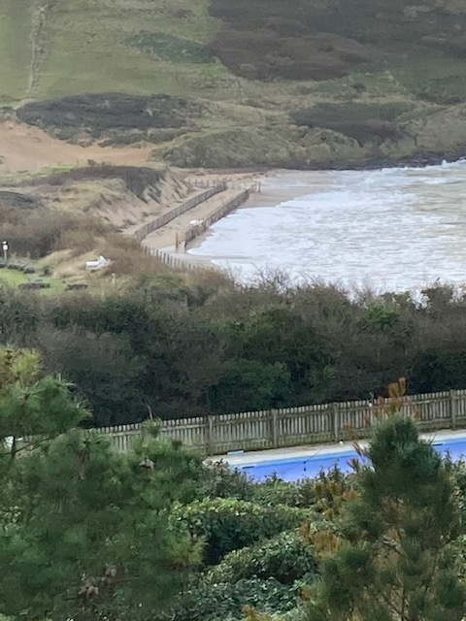
So the Golf Club was contacted by the TRA to express concern and a meeting took place on 18th December. It turned out that the Golf Club had commissioned a thorough-going investigation of the current and likely future state of the dunes from a consultancy with specialist experience of beach erosion and restitution. The consultants’ report was delivered in October 2020. Final decisions have yet to be made about what actions to take, from among a list of options. However, the second line of fencing is due shortly to be removed! As matters develop Members will be kept informed.

The Daymer Bay car park loos were closed early in the New Year following the latest Government lockdown announcement. A new steel entrance door for the Disabled loo is on order, to replace the existing timber door damaged by vandalism. Once this is installed the CIC’s intention is to open the Disabled loo to all users. The Ladies and Gents loos are likely to stay closed until the number of visitors to the beach and environs increases after lockdown is lifted – and of course the timing of this is not yet known. If you wish to make any contribution to the upkeep of the loos, which would be most gratefully received, the details are:
The Daymer Bay Community Interest Company
A/c. No. 31545426
Sort code 40-45-10 (HSBC Wadebridge)

Our most recent Newsletter in November mentioned Simon Reeve’s two-part BBC2 programme including the charitable work being supported by the Cornwall Community Foundation. One of our members wrote back: “We saw the programme and were very moved by it. We started giving monthly to the Cornwall Community Foundation a little while ago and are minded to do similar for the Transformation CPR foodbank in Camborne… we deeply appreciate how lucky we are and do our best to spend all we can on our Trebetherick house locally.” The CCF reported a huge inflow of donations following the broadcast, many from out-of-county – maybe you were one of the donors? Anyone who missed the programme or may want to watch it again can find it still on iPlayer.

Another quite different project of potential interest to members is Kerdroya, the Cornish landscape labyrinth being constructed on Bodmin Moor to commemorate 60 years of the establishment of Areas of Outstanding Natural Beauty. Cornwall has 12 AONB sections, not all contiguous, though there are linking ‘corridors’ – our nearest stretch runs from Pentire Point all along the coast up to Widemouth Bay. The design of the Kerdroya labyrinth has been taken from the carving on the rock face walking down Rocky Valley at Bossiney towards the sea. Its structure will celebrate the Cornish hedge, based on the different vernacular styles across Cornwall which use different types of stone in varying styles and some of which date back millennia. Construction has been badly disrupted by Covid-19, especially as young people including schools are expected to be involved and stonewalling apprenticeships offered. There are environmental conservation objectives too. With luck 2021 will see progress! You can find out much more from your internet browser…

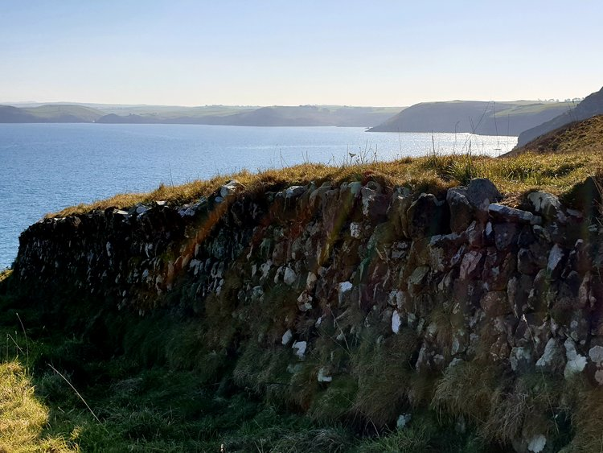

A stretch of Cornish hedge at The Rumps, looking north

A word of warning to anyone who might be tempted to park without paying, however briefly, in the car park overlooking Polzeath beach, opposite the Polzeath Spar – ANPR cameras will track your vehicle down and issue a fine for non-payment.

2020 was a difficult year for so many people. Not least, the TRA was unable to hold the summer party which we hope will become an annual fixture, as a means of members getting to know their fellow residents which are much enjoyed. Other plans for social get-togethers have similarly had to be put on hold. But we have received a generous suggestion from Tony at the Beach Shop for summer evening gigs in their courtyard which sounds wonderful! If you have any other ideas for future gatherings the TRA Committee would be glad to hear from you; please contact Endellion in the first instance and we will get back to you!
endellion.sharpe@btinternet.com
Also any contributions you might have for future Newsletters…

We’ll be in touch again soon! Meanwhile please stay well and safe

TRA Committee

